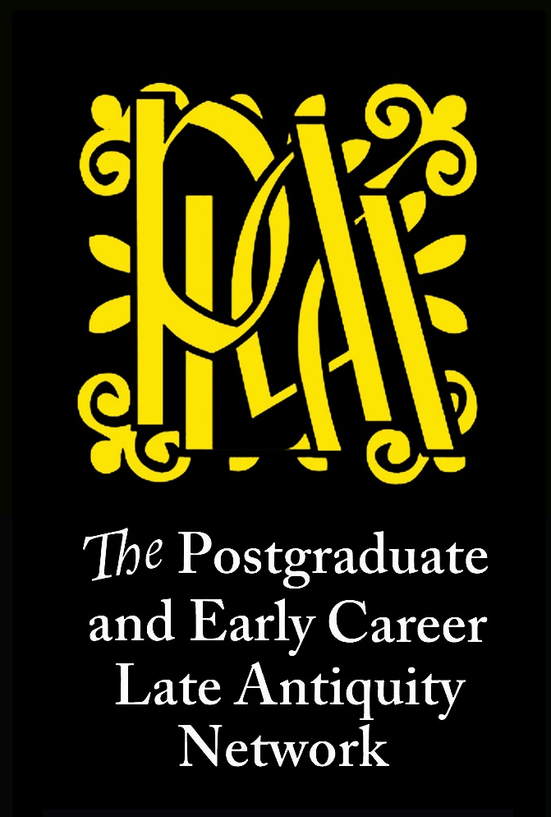
The Postgraduate and Early Career Late Antiquity Network

‘Ideal spaces’

The Postgraduate and Early Career Late Antiquity Network would like to invite contributions to its fifth workshop, to be convened around the theme ‘ideal spaces’ at the Institute of Classical Studies (London) on Monday 14th January 2019.

The workshop, generously supported and hosted by the ICS, aims at providing an informal, but focused and constructive, environment for post-graduate and early career researchers to present their work, meet others working in the field, and discuss current trends and issues. The Network provides a single platform for those working on a broad range of geographical and disciplinary areas within the period of Late Antiquity. We particularly encourage proposals from MA students and graduates in the early stages of their PhD.

This workshop aims to explore late-antique perceptions and conceptualisations of the relationship between real and ideal space(s). We invite proposals for 20-minutes papers that discuss (but are not restricted to) any of the topics below:

- descriptions of alien and/or unexplored lands;

- utopias and dystopias, apocalyptic scenarios;

- the space of the sacred and its conceptualisation;

- gendered spaces, racialised spaces;

- the spaces of life: the functionalisation of the urban and civic environment; anthropised vs. natural spaces;

- philosophical theories of space; metaphysical spaces; linguistic conceptualisations of space;

- spaces as sources of moral or intellectual inspiration; creation of spaces for intellectual exchange;

- idyllic spaces in literature; deconstructions of space; (re)appropriation of spatial language and imagery;

- material supports/codices as idealised spaces;

- transcultural ideas of space in comparison;

Please submit abstracts and any queries to lateantiquenetwork@gmail.com by 20th November 2018. Abstracts should not exceed 300 words. Please include in the email your affiliation (independent scholars are welcome) and your current academic status (or the year in which the PhD was awarded, in the case of early career researches). Successful applications will be notified by 30th November.

Lea Niccolai (Cambridge) & Becca Grose (Reading)

